Experiment 1:DepthknowledgeofDevOps Methodology.
DESCRIPTION:
SDLC:SoftwareDevelopmentLifeCycle.
DevelopmentTeam OperationTeam
TEST
BUILD
CODE
PLAN
MAINTAIN
OPERATIONS
DELAY

Waterfall Methodology: The waterfall methodology- also known as waterfall- model is asequential development process that flows all like a waterfall through all phases of a project(analysis,design,development,andtesting)witheachphasecompletelywrappingupbeforethenextphasebegins
Advantages:
- Simpleandeasytounderstandand use.
- Easytomanageduetotherigidityof themodel.
- Phasesareprocessedoneatatime.
- Workswellforsmallprojectswhereallrequirementsareverywellunderstood.

Disadvantages:
- You can go back a step, if the design phase has gone wrong, things can get verycomplicatedintheimplementationphase.
- Highamountsofriskanduncertainty.
- Notagoodmodelforcomplexobject-orientedprojects.
- Poormodelforlongandon-goingprojects.
AgileMethodology:
- Itisapractice thatpromotes continuousiterationsofdevelopmentandtestingthroughoutthesoftwaredevelopmentlifecycleof theproject.
- Bothdevelopmentandtestingactivitiesareconcurrent,unlikethewaterfallmodel.
- Timelineoftheproject isfixed.
- Whiletheagileapproachbroughtagilitytodevelopment,itwaslastonoperationswhichdidnotcomeuptospeedwithagilepractices.
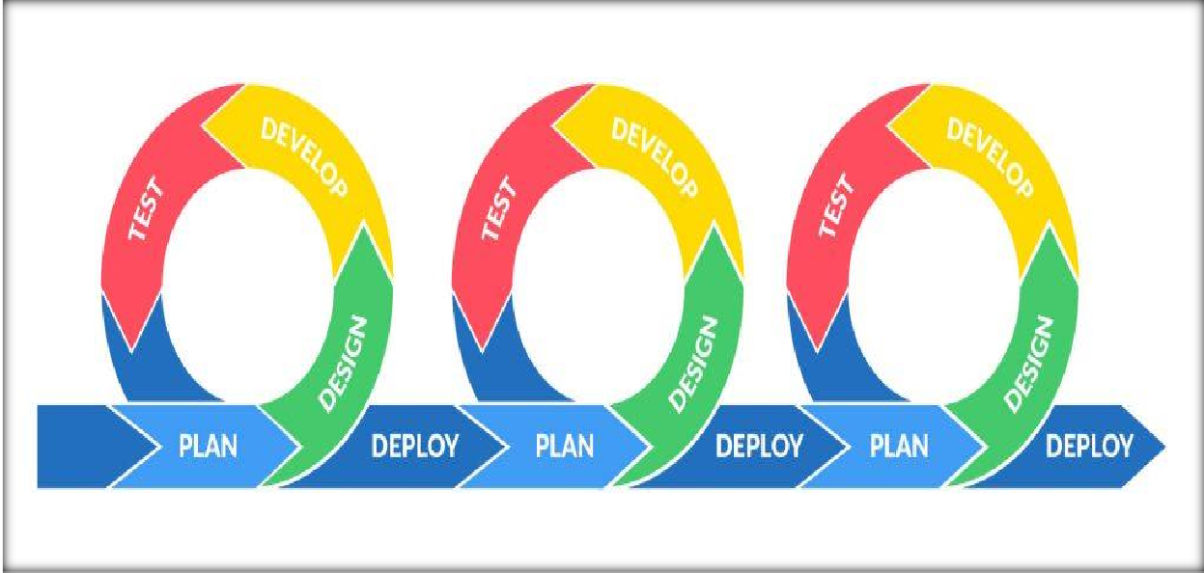

DevOpsHistory:
- DevOpswasoriginatedintheyear2008.
- Originally itwasadiscussionbetweentwopeople calledAndrewClayandPatrickDebios.
- In 2009, they held a summit at Belgium there they have discussed was it DevOpscomes tothemarket.
- In2014,theannualstateofDevOpsreportwaspublished.
- ItDevOpshasbirthcertificate;the fathersname wouldbepennedinasPatrickDebios.

WhatDevOpsEngineerdo?
- DevOpsengineerissomebodywhounderstandsthesoftwaredevelopmentlifecycleand has the outright understanding of various operation tools for developing digitalpipelines (CI/COpipelines).
- DevOpsengineeringworkswithdevelopsandITstafftooverseethecodereleases.
- Heintroducesnewmethodologiestoimplementprocessquickly.
- Hehasknowledgeofbothdevelopmentteamandoperationteamaswell.
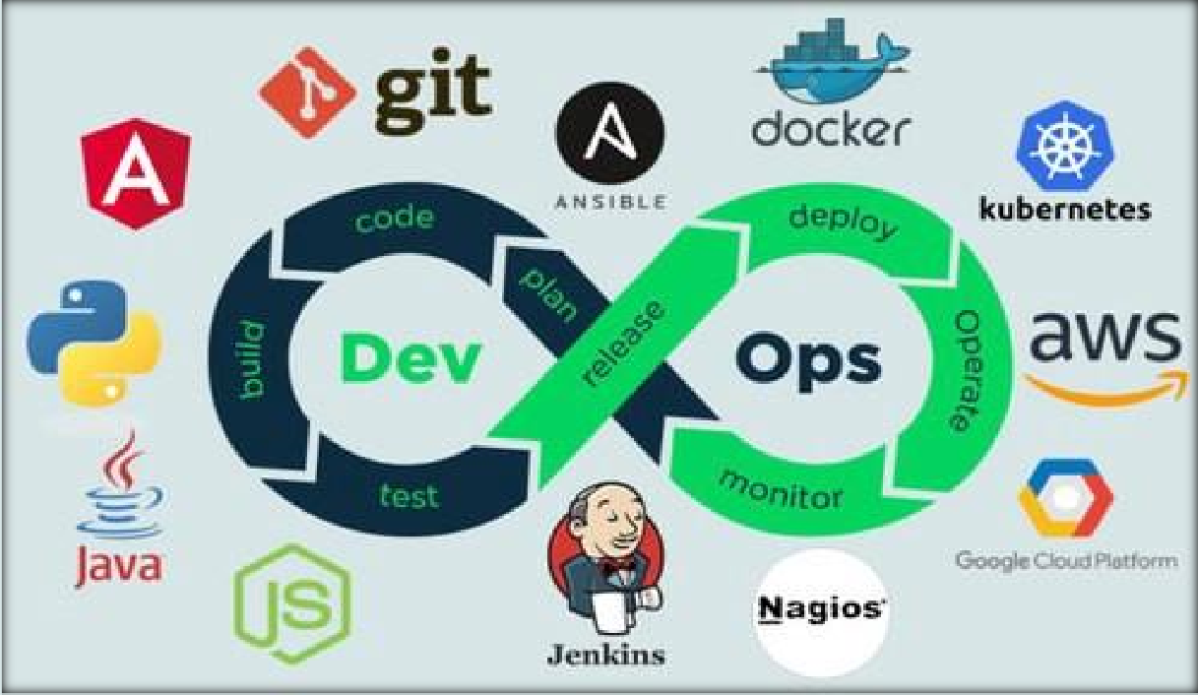
RequiredtoolsforDevOpsMethodology:
- Junit
- Maven
- Git
- SVN
- CHEF
- Grandle
- Sensu
- Puppet
- Jenkins
- Docker
- JIRA
- Selenium
- Ansible
- Splunk
- SaltSTACK
- Eclipse
- Bamboo

